CHAPTER 6
DISCRETE PROBABILITY DISTRIBUTIONS

SECTION EXERCISES
6.1 d/p/e A random variable is described as "random" because we don't know ahead of time exactly what value it will have following the experiment.

6.2 d/p/m
a. Continuous. This is an exact measurement that could take on any value within an interval.
b. Discrete. The words "number of" and "completed" are the keys to this conclusion.
"Number of" implies a variable that can be counted. "Completed" infers the use of
end-of-year ceremonies or class graduations as events that are counted.
c. Continuous. Although it is expressed to two decimal places, the DJIA is the result of
rounding the average price of the stocks in the index.
d. Discrete. In the U.S., milk is typically sold in half-pints, pints, quarts, half gallons and gallons.

6.3 d/p/m
a. Discrete. There can't be a fraction of a customer.
b. Continuous. Although the total cannot include a fraction of a penny, there are so many
possibilities that, for practical purposes, this random variable can be considered continuous.
c. Discrete. Although the passage of time is continuous, a digital watch reports it as discrete; e.g.,
there is a one-second gap between the 10:25:12 display and the 10:25:13 display.
d. Continuous. This is an exact measurement that could take on any value within an interval.

6.4 d/p/m Exhaustive means that the probability distribution includes all possible values of x.
Mutually exclusive means that only one value of x can occur for a given experiment.

6.5 c/a/m Mean: 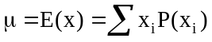 = 3(0.2) + 8(0.7) + 10(0.1) = 7.2
Variance: 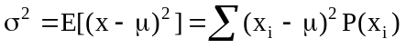
= (3 - 7.2)²(0.2) + (8 - 7.2)²(0.7) + (10 - 7.2)²(0.1) = 4.76
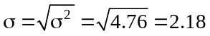
x_{i} | P(x_{i}) | x_{i}P(x_{i}) | (x_{i} - μ)² P(x_{i})
3 | 0.20 | 0.60 | 3.53
8 | 0.70 | 5.60 | 0.45
10 | 0.10 | 1.00 | 0.78
 | 1.0 | 7.20 | 4.76

6.6 c/a/m Mean: = 0(0.60) + 1(0.30) + 2(0.10) = 0.50
Variance:
= (0 - 0.5)²(0.60) + (1 - 0.5)²(0.30) + (2 - 0.5)²(0.10)
= 0.450 and 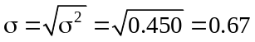
x_{i} | P(x_{i}) | x_{i}P(x_{i}) | (x_{i} - μ)² P(x_{i})
0 | 0.60 | 0.00 | 0.150
1 | 0.30 | 0.30 | 0.075
2 | 0.10 | 0.20 | 0.225
 | 1.0 | 0.50 | 0.450
6.7 c/a/m Mean: = 0(0.1) + 1(0.3) + 2(0.3) + 3(0.2) + 4(0.1) = 1.9
Variance:
= (0 - 1.9)²(0.1) + (1 - 1.9)²(0 .3) + (2 - 1.9)²(0.3) + (3 – 1.9)²(0.2) + (4 - 1.9)²(0.1)
= 1.29 and 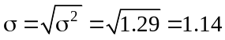
x_{i} | P(x_{i}) | x_{i}P(x_{i}) | (x_{i} - μ)² P(x_{i})
0 | 0.10 | 0.00 | 0.361
1 | 0.30 | 0.30 | 0.243
2 | 0.30 | 0.60 | 0.003
3 | 0.20 | 0.60 | 0.242
4 | 0.10 | 0.40 | 0.441
 |  | 1.90 | 1.290

6.8 p/a/m For x = Ed’s salary next year, the probability distribution of x is:
x_{i} | P(x_{i}) | x_{i}P(x_{i})
$200,000 | 0.60 | 120,000
$120,000 | 0.40 | 48,000
 | 1.0 | $168,000
Ed’s expected salary for next year is 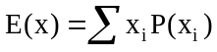 = 200,000(0.6) + 120,000(0.4) = $168,000.

6.9 p/a/m For x = Marlin’s monetary outcome for staging this scam, the probability distribution of x is:
x_{i} | P(x_{i}) | x_{i}P(x_{i})
-$500 | 0.1 | -50
$0 | 0.3 | 0
$100 | 0.6 | 60
 | 1.0 | $10
Marlin’s expected monetary outcome is = -500(0.1) + 0(0.3) + 100(0.6) = $10.

6.10 p/a/m For x = the number of coupons received by a counter employee, the probability distribution of x is:
x_{i} | P(x_{i}) | x_{i}P(x_{i})
0 | 0.40 | 0.00
1 | 0.60 | 0.60
 | 1.0 | 0.60
Mean: = 0(0.4) + l(0.6) = 0.6 coupons

6.11 p/a/m The discrete random variable is x = the number of additional employees that must be hired. The probability distribution for x is:
x_{i} | P(x_{i}) | x_{i}P(x_{i})
1 | 0.1 | 0.1
2 | 0.5 | 1.0
5 | 0.4 | 2.0
 | 1.0 | 3.1
Mean: = l(0.1) + 2(0.5) + 5(0.4) = 3.1 new employees

6.12 p/a/m Let x be the amount the buyer expects to pay given the construction time required.
 | x_{i} | P(x_{i}) | x_{i}P(x_{i})
more than 16 wks. | $510,000 | 0.20 | 102,000
less than 8 wks. | $560,000 | 0.30 | 168,000
between 8 and 16 wks. | $550,000 | 0.50 | 275,000
 |  | 1.00 | $545,000
The amount the buyer expects to pay is = $545,000.

6.13 p/a/m Let x = profit per disc; the profit will be $9 minus $1 times the number of dots that show up on the rolled die.
No. of dots | Sale Price | x_{i} = Net Profit | P(x_{i}) | x_{i}P(x_{i})
1 | $8 | $3.00 | 0.166667 | 0.50
2 | $7 | $2.00 | 0.166667 | 0.33
3 | $6 | $1.00 | 0.166667 | 0.17
4 | $5 | $0.00 | 0.166667 | 0.00
5 | $4 | - $1.00 | 0.166667 | -0.17
6 | $3 | -$2.00 | 0.166667 | -0.33
 |  |  | 1.0 | $0.50
= $0.50 profit per sale

6.14 p/a/m
a. If Laura does not purchase flood insurance, her expected profit next year will be
= 200,000(0.99) - 1,000,000(0.01) = $188,000
b. If Laura purchases flood insurance, her expected profit next year will be
= 190,000(0.99) + 200,000(0.01) = $190,100
c. Laura’s expected profit will be higher if she purchases flood insurance.

6.15 p/a/m
If Transco does not renovate the plant, the expected profit will be
= 35(.3) + 38(.5) + 42(.2) = $37.9 million
If Transco carries out minor plant renovations, the expected profit will be
= 28(.3) + 45(.5) + 55(.2) = $41.9 million
If Transco carries out major plant renovations, the expected profit will be
= 21(.3) + 40(.5) + 70(.2) = $40.3 million
Transco’s expected profit will be highest if it carries out minor plant renovations.

6.16 d/p/e (1) There are two or more consecutive trials. (2) On each trial, there are just two possible outcomes – a "success" or a "failure." (3) The trials are statistically independent; that is, the outcome in any trial is not affected by the outcomes of earlier trials, and it does not affect the outcomes of later trials. (4) The probability of a "success" stays the same from one trial to the next.

6.17 d/p/m As a rule of thumb, if the population is at least 20 times as large as the number of trials, we assume that the “constant π” assumption has been satisfactorily met.

6.18 c/a/m
a. 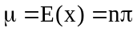 = 7(0.7) = 4.9
b. 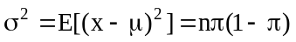 = 7(0.7)(1 - 0.7) = 1.47 and 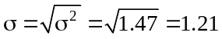
c. This answer and the ones that follow can also be obtained from the table of individual binomial probabilities, or by using a computer software package. The Minitab result is shown below.

Using Minitab (see the x = 3 row):

Binomial with n = 7 and p = 0.700000
x P( X = x)
0 0.0002
1 0.0036
2 0.0250
3 0.0972
4 0.2269
5 0.3177
6 0.2471
7 0.0824

Using the binomial formula and a calculator:
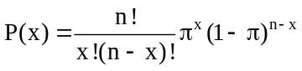 and 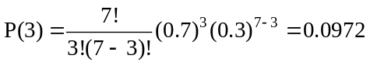

d. P(3 ≤ x ≤ 5) = P(x = 3) + P(x = 4) + P(x = 5) = 0.6418

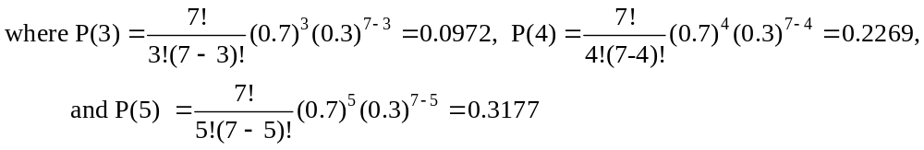

e. P(x > 4) = P(x = 5) + P(x = 6) + P(x = 7) = 0.6472

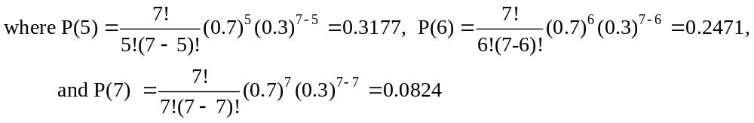
(Reminder: In calculating P(7), 0! = 1 and 0.3⁰ = 1.)

6.19 c/a/m
a. = 12(0.3) = 3.6
b. = 12(0.3)(1 - 0.3) = 2.52 and 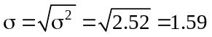
c. Using Minitab:

Binomial with n = 12 and p = 0.300000
x P( X = x)
0 0.0138
1 0.0712
2 0.1678
3 0.2397
(partial printout)

Using a pocket calculator and the binomial formula in the text:
d. Using either the cumulative binomial tables or the Minitab printout shown below:

Using the cumulative binomial tables in the back of the text.
P(2 ≤ x ≤ 8) = P(x ≤ 8) - P(x ≤ 1) = 0.9983 - 0.0850 = 0.9133

Using Minitab, refer to the printout and find P(x ≤ 8) - P(x ≤ 1)

Binomial with n = 12 and p = 0.300000
x P( X <= x)
0 0.0138
1 0.0850
2 0.2528
3 0.4925
4 0.7237
5 0.8822
6 0.9614
7 0.9905
8 0.9983
9 0.9998
10 1.0000

e. P(x > 3) = 1 - P(x ≤ 3) = 1 - 0.4925 = 0.5075

6.20 c/a/m
a. The probability that x = 0 of Ralph's n = 4 purchases has been stolen can be calculated as:

Using the binomial formula:

Using the individual binomial probabilities or the Minitab printout below:

Binomial with n = 4 and p = 0.200000
x P( X = x)
0 0.4096
1 0.4096
2 0.1536
3 0.0256
4 0.0016

b. Using the individual binomial probabilities in part a,
P(2 ≤ x) = P(x = 2) + P(x = 3) + P(x = 4) = 0.1536 + 0.0256 + 0.0016 = 0.1808
c. Using the individual binomial probabilities in part a,
P(1 ≤ x ≤ 3) = P(x = 1) + P(x = 2) + P(x = 3) = 0.4096 + 0.1536 + 0.0256 = 0.5888
d. Using the individual binomial probabilities in part a,
P(x ≤ 2) = P(x = 0) + P(x = 1) + P(x = 2) = 0.4096 + 0.4096 + 0.1536 = 0.9728

The cumulative binomial probabilities (either from tables or the computer) could also have been used in obtaining these results.

6.21 p/a/m From exercise 6.10, n = 5 and the probability of receiving a coupon is 0.60. Use the table of individual binomial probabilities or the Minitab printout below.

Binomial with n = 5 and p = 0.600000
x P( X = x)
0 0.0102
1 0.0768
2 0.2304
3 0.3456
4 0.2592
5 0.0778

a. P(x = 0) = 0.0102 b. P(x = 2) = 0.2304 c. P(x = 3) = 0.3456 d. P(x = 5) = 0.0778

6.22 p/a/m With n = 20, π = 0.50, the cumulative probabilities can be found in the binomial tables or determined with computer assistance, as shown in the Minitab printout below.

Binomial with n = 20 and p = 0.500000
x P( X <= x)
1 0.0000
2 0.0002
3 0.0013
4 0.0059
5 0.0207
6 0.0577
7 0.1316
8 0.2517
9 0.4119
10 0.5881
11 0.7483
12 0.8684
13 0.9423
14 0.9793
(partial printout)

a. The expected value of x is E(x) = nπ = 20(0.50) = 10.0.
b. P(x ≤ 8) = 0.2517
c. P(x = 10) = P(x ≤ 10) - P(x ≤ 9) = 0.5881 - 0.4119 = 0.1762.
d. P(x = 12) = P(x ≤ 12) - P(x ≤ 11) = 0.8684 - 0.7483 = 0.1201
e. P(7 ≤ x ≤ 13) = P(x ≤ 13) - P(x ≤ 6) = 0.9423 - 0.0577 = 0.8846

6.23 p/a/m Binomial experiment with n = 3, π = 0.01. Let x = number of Andersons chosen.
Shown below are the Minitab and binomial formula approaches.

Binomial with n = 3 and p = 0.0100000
x P( X = x)
0 0.9703
1 0.0294
2 0.0003
3 0.0000

a. P(x = 0)
Using the binomial formula:
Using Minitab, P(x = 0) = 0.9703 from the first line of the output.
b. Using the individual probabilities in the printout, P(x = 1) = 0.0294
c. Using the individual probabilities in the printout, P(x = 2) = 0.0003
d. Using the individual probabilities in the printout, P(x = 3) = 0.0000

6.24 p/a/m With n = 5, π = 0.65, the probabilities can be computed by formula or by using the computer. The Minitab cumulative and individual probabilities are shown below.

Binomial with n = 5 and p = 0.65
x P( X <= x )
0 0.00525
1 0.05402
2 0.23517
3 0.57159
4 0.88397
5 1.00000

Binomial with n = 5 and p = 0.65
x P( X = x )
0 0.005252
1 0.048770
2 0.181147
3 0.336416
4 0.312386
5 0.116029

a. From the printout of cumulative probabilities, P(x ≥ 2) = 1 - P(x ≤ 1) = 1 - 0.05402 = 0.94598.
b. From the printout of individual probabilities, P(x = 5) = 0.116029

6.25 p/a/m With n = 4, π = 0.50, the Minitab table of cumulative probabilities is shown below.

Binomial with n = 4 and p = 0.5
x P( X <= x )
0 0.0625
1 0.3125
2 0.6875
3 0.9375
4 1.0000

a. P(x ≤ 3) = 0.9375
b. P(x ≥ 2) = 1 - P(x ≤ 1) = 1 - 0.3125 = 0.6875

6.26 p/a/m With n = 3, π = 0.30, the individual probabilities can be found in the binomial tables.
Minitab is used below.

Binomial with n = 3 and p = 0.300000
x P( X = x )
0.00 0.3430
1.00 0.4410
2.00 0.1890
3.00 0.0270

6.27 p/a/m With n = 3, π = 0.50, the individual probabilities can be found in the binomial tables or determined with computer assistance, as shown in the Minitab printout below.

Binomial with n = 3 and p = 0.500000
x P( X = x )
0.00 0.1250
1.00 0.3750
2.00 0.3750
3.00 0.1250

For Alicia, P(x = 0) is 0.1250; P(x = 3 ) is 0.1250; and P(x = 1) is 0.3750.

6.28 p/a/m With n = 4, π = 0.40, the individual probabilities can be found in the binomial tables or determined with computer assistance, as shown in the Minitab printout below.

Binomial with n = 4 and p = 0.400000
x P( X = x )
0.00 0.1296
1.00 0.3456
2.00 0.3456
3.00 0.1536
4.00 0.0256

The probabilities that the company will receive 0, 1, 2, 3, or 4 contracts are shown in the printout.
The expected profit for the company in this venture is
= 0(0.1296) + 50,000(0.3456) + 100,000(0.3456) + 150,000(0.1536)
+ 200,000(0.0256) = $80,000

6.29 p/a/m With n = 4, π = 0.10, the individual probabilities can be found in the binomial tables or determined with computer assistance, as shown in the Minitab printout below.

Binomial with n = 4 and p = 0.100000
x P( X = x )
0.00 0.6561
1.00 0.2916
2.00 0.0486
3.00 0.0036
4.00 0.0001

The probability that x = 0 of the four wheel bearings will fail is 0.6561. The probability that one or more of the bearings will fail and result in the truck breaking down is 1 - 0.6561, or 0.3439.

6.30 p/a/m With n = 10, π = 0.20, the cumulative probabilities can be found in the binomial tables or determined with computer assistance, as shown in the Minitab printout below.

Binomial with n = 10 and p = 0.200000
x P( X <= x )
0.00 0.1074
1.00 0.3758
2.00 0.6778
3.00 0.8791
4.00 0.9672
5.00 0.9936
6.00 0.9991
7.00 0.9999
8.00 1.0000
9.00 1.0000

With x = the number of students in the dinner group who suffer from allergies, the probability that at least 8 of the students will be able to stay for the entire event is P(x ≤ 2) = 0.6778.

6.31 p/a/d
a. The probability that Emily will be bumped is 0.0014.
b. For any individual, the probability of not being bumped is 1 - 0.0014 = 0.9986. The probability that x = 0 of the 10 travelers will make the trip without being bumped is 0.9986¹⁰ = 0.9861. Thus, the probability that at least one person will be bumped is 1 - 0.9861, or 0.0139. The same result can be obtained by using the Minitab probabilities below.

Binomial with n = 10 and p = 0.0014

x P( X = x )
0 0.986088
1 0.013825
2 0.000087
3 0.000000
4 0.000000

c. With n = 220 and π = 0.0014, computer assistance will be much more convenient than using a pocket calculator, and the Minitab cumulative probabilities are shown below.

Binomial with n = 220 and p = 0.0014

x P( X <= x )
0 0.73476
1 0.96138
2 0.99617
3 0.99971
4 0.99998
5 1.00000

If last year’s 220-flight total were to be repeated over an extremely large number of years, the probability of x ≥ 4 bumps in any given year would be just 1 - 0.99971 = 0.00029 or, to four decimal places, 0.0003. Yes, the company’s experience last year was extremely unusual.

6.32 p/a/d For n = 5 statues produced per day and π = 0.10 as the probability any given statue will be defective and have to be sent to the specialist, the probability distribution for x = the number of defective statues per day is shown below.

Binomial with n = 5 and p = 0.100000
x P( X = x )
0.00 0.5905
1.00 0.3281
2.00 0.0729
3.00 0.0081
4.00 0.0005
5.00 0.0000

Given the above probabilities and considering that the specialist receives $20 for each defective unit,
the probability distribution for the specialist’s daily fee is shown below.
Probability | Fee
0.5905 | $0
0.3281 | 20
0.0729 | 40
0.0081 | 60
0.0005 | 80
0.0000 | 100

The average number of defects per day is nπ = 5(0.10) = 0.5 defects per day, so the average daily fee to the specialist will be 0.5($20) = $10. This can also be calculated as from the probability distribution shown above.

6.33 d/p/e The hypergeometric distribution is used instead of the binomial when the consecutive trials are not independent – i.e., when the probability of a success is not constant from one trial to the next. For example, when sampling is done without replacement and the population is not very large, the probability of a "success" can change quite drastically from one trial to the next.

6.34 c/a/m
a. Of the N = 4 items in the population, s = 3 are successes. In a sample of n = 2, at least one must be a success. Thus, P(x = 0) is 0. Using the formula with x = 0 yields an undefined expression in the 2nd combinatorial expression in the numerator.

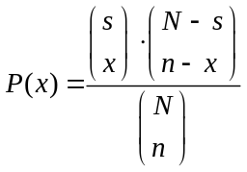, 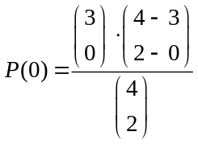=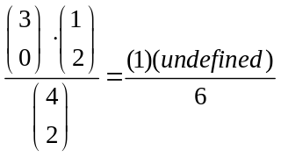

b. To find P(x = 1), 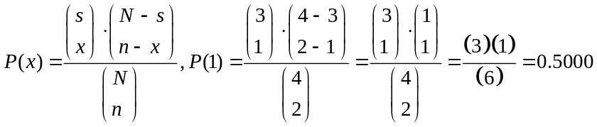

c. To find P(x = 2), 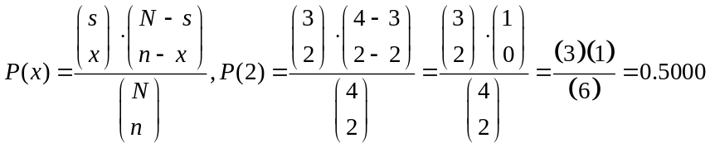

The corresponding Excel and Minitab results are shown below.

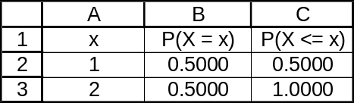

Hypergeometric with N = 4, M = 3, and n = 2
x P( X = x )
0 0.0
1 0.5
2 0.5

6.35 c/a/m Of the N = 5 items in the population, s = 3 are successes, and the sample size is n = 2.

a. P(x = 0), 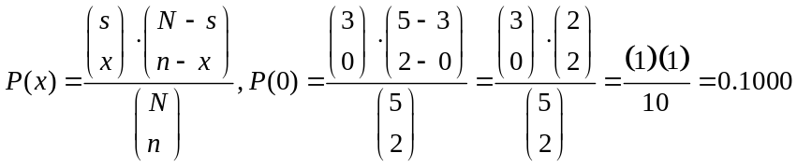

b. P(x = 1), 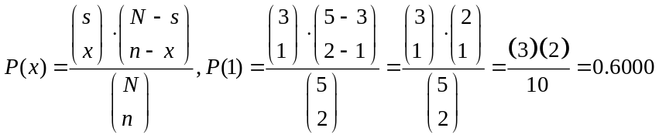

c. P(x = 2), 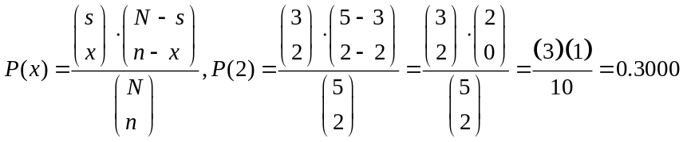

The corresponding Excel and Minitab probabilities are shown below.

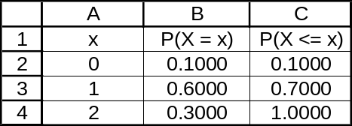

Hypergeometric with N = 5, M = 3, and n = 2
x P( X = x )
0 0.1
1 0.6
2 0.3

6.36 p/a/m The size of the population is N = 25 and the sample size is n = 12. With male = “success,” the number of successes in the population is s = 11. For x = the number of successes in the sample, the probability that the jury will include at least 6 males is P(x ≥ 6). Using the hypergeometric formula and a pocket calculator, we obtain the following individual probabilities:

P(x = 6), 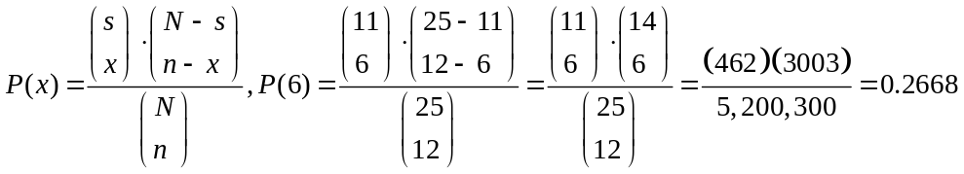

P(x = 7), 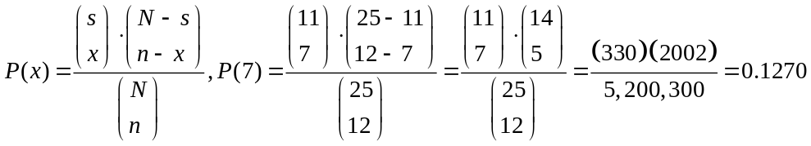
P(x = 8), 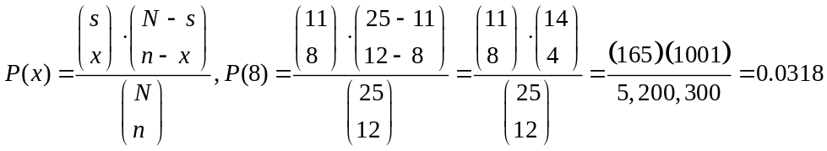

P(x = 9), 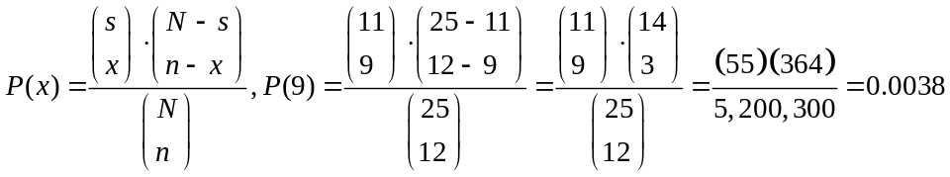

P(x = 10), 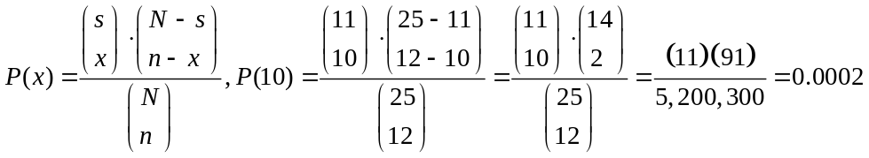

P(x = 11), 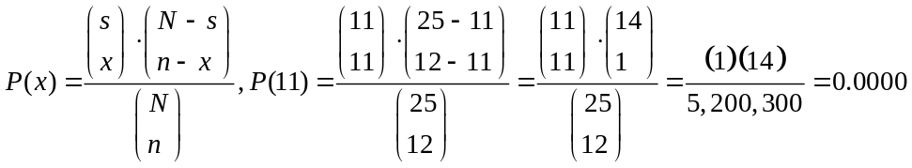

P(x = 12) = 0.0000. We can not have 12 successes in the sample, because there are only 11 successes in the population.

We can determine P(x ≥ 6) by adding the preceding probabilities or by using the computer and calculating P(x ≥ 6) as 1 - P(x ≤ 5). Referring to either the Excel or the Minitab cumulative probabilities, we can calculate P(x ≥ 6) as 1 - P(x ≤ 5) = 1 - 0.5704, or P(x ≥ 6) = 0.4296.

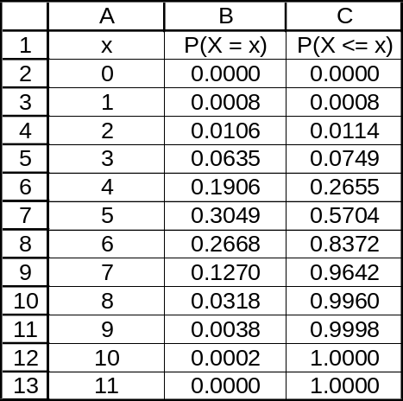

Hypergeometric with N = 25, M = 11, and n = 12
x P( X = x )
0 0.000017
1 0.000770
2 0.010587
3 0.063521
4 0.190564
5 0.304902
6 0.266790
7 0.127043
8 0.031761
9 0.003850
10 0.000192
11 0.000003
12 0.000000

Hypergeometric with N = 25, M = 11, and n = 12
x P( X <= x )
0 0.00002
1 0.00079
2 0.01137
3 0.07490
4 0.26546
5 0.57036
6 0.83715
7 0.96419
8 0.99596
9 0.99980
10 1.00000
11 1.00000
12 1.00000

6.37 p/a/m With N = 5, n = 3, and s = 2, the probability that at least one of the persons selected will have strong interpersonal skills is P(x = 1) + P(x = 2). Formula calculations are shown below, along with the corresponding Excel and Minitab results. The probability that at least one of the participants will have strong interpersonal skills is P(x = 1) + P(x = 2) = 0.6000 + 0.3000 = 0.9000.

P(x = 1), 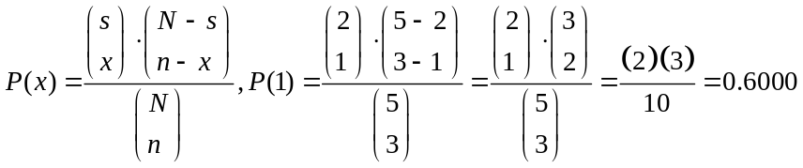

P(x = 2), 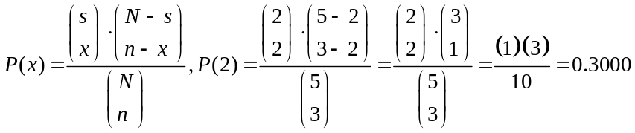

Hypergeometric with N = 5, M = 2, and n = 3
x P( X = x )
0 0.1
1 0.6
2 0.3

Hypergeometric with N = 5, M = 2, and n = 3
x P( X <= x )
0 0.1
1 0.7
2 1.0

6.38 p/a/m With N = 12, n = 5, and s = 3, the probability that exactly one of the recall-affected cars will be rented today can be calculated as:

P(x = 1), 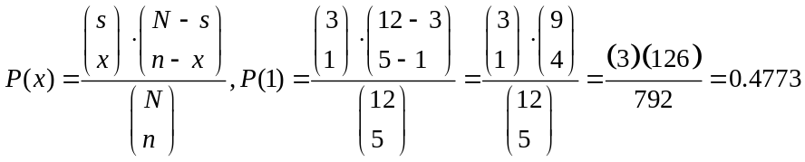

The probability that all three of the recall-affected cars will be rented today can be calculated as:

P(x = 3), 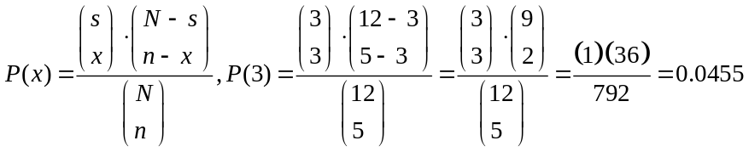

The corresponding Excel and Minitab results are shown below.
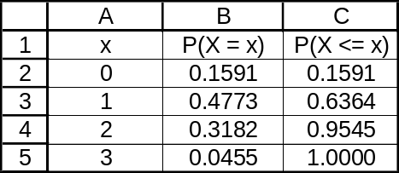

Hypergeometric with N = 12, M = 3, and n = 5
x P( X = x )
0 0.159091
1 0.477273
2 0.318182
3 0.045455

Hypergeometric with N = 12, M = 3, and n = 5
x P( X <= x )
0 0.15909
1 0.63636
2 0.95455
3 1.00000

6.39 c/a/m Using the Poisson formula, with λ = 2.0, the Poisson probabilities can be computed with the formula or obtained with computer assistance. Using Minitab, the individual Poisson probabilities are shown below.

Poisson with mu = 2.00000
x P( X = x)
0 0.1353
1 0.2707
2 0.2707
3 0.1804
4 0.0902
5 0.0361
6 0.0120
7 0.0034
8 0.0009
9 0.0002
10 0.0000

a.

b.

c.

Thus, P(x ≤ 3) = P(x = 0) + P(x = 1) + P(x = 2) + P(x = 3)
= 0.1353 + 0.2707 + 0.2707 + 0.1804 = 0.8571

d. P(x ≥ 2) = 1 - P(x ≤ 1) = 1 - [P(x = 0)+ P(x = 1)] = 1- [0.1353 + 0.2707]
= 1 - 0.4060 = 0.5940

6.40 c/a/m Using λ = 9.6, the Poisson probabilities can be found by using the computer or by referring to the individual and cumulative Poisson tables in the text.
a. Using the "9.6" column of individual probabilities, P(x = 7) = 0.1010.
b. Using the "9.6" column of individual probabilities, P(x = 9) = 0.1293.
c. Using the "9.6" column of cumulative probabilities, P(x ≤ 12) = 0.8279.
d. Using the "9.6" column of cumulative probabilities, P(x ≥ 10) = 1 - P(x ≤ 9) = 1 - 0.5089
= 0.4911.

6.41 p/a/m
a. Let π = 490/100,000 = 0.0049. The expected value of x is E(x) = λ = nπ
= 1000(0.0049) = 4.9.

b. P(x = 3) = 0.1460 has been determined by referring to the individual probabilities in the Minitab printout, below left. The cumulative probabilities are shown in the printout on the right.

Poisson with mean = 4.9 Poisson with mean = 4.9

x P( X = x ) x P( X <= x )
0 0.007447 0 0.00745
1 0.036488 1 0.04393
2 0.089396 2 0.13333
3 0.146014 3 0.27934
4 0.178867 4 0.45821
5 0.175290 5 0.63350
6 0.143153 6 0.77665
7 0.100207 7 0.87686
8 0.061377 8 0.93824
9 0.033416 9 0.97166
10 0.016374 10 0.98803
11 0.007294 11 0.99532
12 0.002978 12 0.99830
13 0.001123 13 0.99942
14 0.000393 14 0.99982
15 0.000128 15 0.99995
16 0.000039 16 0.99998
17 0.000011 17 1.00000

c. Using the individual probabilities in part b, P(x = 5) = 0.1753.
d. Using the cumulative probabilities in part b, P(x ≤ 8) = 0.9382.
e. Using the cumulative probabilities in part b, P(3 ≤ x ≤ 10) = P(x ≤ 10) - P(x ≤ 2)
= 0.98803 - 0.13333 = 0.8547.

6.42 p/a/m
a. The expected value of x is E(x) = λ =2.5 potential customers.
b. P(x = 1) = 0.2052. Using λ = 2.5, the Poisson probabilities can be found by using the computer or by referring to the individual and cumulative Poisson tables in the text.
c. Using the "2.5" column of individual probabilities, P(x = 3) = 0.2138.
d. Using the "2.5" column of cumulative probabilities, P(x ≤ 5) = 0.9580.
e. Using the "2.5" column of cumulative probabilities,
P(2 ≤ x ≤ 6) = P(x ≤ 6) - P(x ≤ 1) = 0.9858 – 0.2873 = 0.6985.

6.43 p/a/m
a. Let λ = expected value of x, and E(x) = 3.6(500/1000) = 1.8 divorces.
b. Using λ = 1.8, the Poisson probabilities can be found by using the computer or by referring to the individual and cumulative Poisson tables in the text. From the individual tables, P(x = 1) = 0.2975.
c. Using the "1.8" column of individual probabilities, P(x = 4) = 0.0723.
d. Using the "1.8" column of cumulative probabilities, P(x ≤ 6) = 0.9974.
e. Using the "1.8" column of cumulative probabilities,
P(2 ≤ x ≤ 5) = P(x ≤ 5) - P(x ≤ 1) = 0.9896 - 0.4628 = 0.5268.

6.44 p/a/m
a. The expected value of x is E(x) = λ = 1.3 arrivals.
b. P(x = 0) = 0.2725 can be found by using either the Poisson probability tables or the computer.
c. Using the "1.3" column of individual probabilities, P(x = 1) = 0.3543.
d. Using the "1.3" column of cumulative probabilities, P(x ≤ 2) = 0.8571.
e. Using the "1.3" column of cumulative probabilities,
P(1 ≤ x ≤ 3) = P(x ≤ 3) - P(x ≤ 0) = 0.9569 - 0.2725 = 0.6844.

6.45 p/a/m The expected number of emergency calls tomorrow is E(x) = λ = 3.1 calls. We can refer to the cumulative Poisson probabilities in text Appendix A or use the computer. The Minitab cumulative probabilities are shown below. Because Howard can handle up to 8 calls, the probability that he will receive more calls than he can handle is P(x ≥ 9) = 1 - P(x ≤ 8) = 1 - 0.9953 = 0.0047. Considering this extremely low probability, Howard might want to consider a slight reduction in the level of personnel and equipment he devotes to handling emergency calls.

Poisson with mu = 3.10000
x P( X <= x )
0.00 0.0450
1.00 0.1847
2.00 0.4012
3.00 0.6248
4.00 0.7982
5.00 0.9057
6.00 0.9612
7.00 0.9858
8.00 0.9953
9.00 0.9986
10.00 0.9996
11.00 0.9999
12.00 1.0000

6.46 p/a/m The expected number of viruses next week is E(x) = λ = 0.4 viruses. We can refer to the individual Poisson probabilities in text Appendix A or use the computer. The Minitab individual probabilities are shown below. The probability that there will be no viruses at all next week is
P(x = 0) = 0.6703. Each virus that occurs costs $1000 for removal and repair, so the expected amount of money the university will have to spend on these operations next week is the product of the expected number of viruses times the cost per virus, or (0.4)($1000) = $400.

Poisson with mu = 0.400000
x P( X = x )
0.00 0.6703
1.00 0.2681
2.00 0.0536
3.00 0.0072
4.00 0.0007
5.00 0.0001
6.00 0.0000

6.47 p/a/m
a. Let λ = expected value of x. This is nπ = 500(0.02) = 10.0 foreclosures.
b. P(x = 7) = 0.0901 can be found by using either the Poisson probability tables or the computer.
c. Using the "10.0" column of individual probabilities, P(x = 10) = 0.1251.
d. Using the "10.0" column of cumulative probabilities, P(x ≤ 12) = 0.7916.
e. Using the "10.0" column of cumulative probabilities,
P(8 ≤ x ≤ 15)= P(x ≤ 15) - P(x ≤ 7) = 0.9513 - 0.2202 = 0.7311.

6.48 p/a/m On the basis of 500 passengers, the mean is 6.06(500/1000), or 3.03. For a Poisson distribution with λ = 3.03, the approximate cumulative probabilities for x = number of people whose baggage is mishandled can be obtained by using the Poisson cumulative probability tables for the nearest listed value (3.0). For more accurate results, we will use the computer and the Minitab printout below for x values between 2 and 6.

Poisson with mean = 3.03

x P( X <= x )
2 0.416503
3 0.640511
4 0.810197
5 0.913027
6 0.964956

The probability that at least 5 people on this flight will have their baggage mishandled is
P(x ≥ 5) = 1 - P(x ≤ 4) = 1 - 0.810197 = 0.189803, or (to four decimal places), or 0.1898. The probability that no more than 3 people will have their baggage mishandled is (to four decimal places) 0.6405.

6.49 p/a/m On the basis of 3000 drivers, the mean is 30.0(3000/100,000), or 0.9. For a Poisson distribution with λ = 0.9, the cumulative probabilities for x = number of drivers murdered on the job can be obtained using either the Poisson cumulative probability tables or the computer. Shown below is the Minitab printout for x values between 0 and 4.

Poisson with mu = 0.900000
x P( X <= x )
0.00 0.4066
1.00 0.7725
2.00 0.9371
3.00 0.9865
4.00 0.9977

The probability that at least 2 of the city’s drivers will be murdered on the job next year is
P(x ≥ 2) = 1 - P(x ≤ 1) = 1 - 0.7725, or 0.2275. The expected amount the city will be providing to families of murdered drivers next year is E(x)*50,000 = 0.9(50,000) = $45,000.

6.50 p/a/m For a Poisson distribution with λ = 2.4, the cumulative probabilities for x = number of breakdowns per day can be obtained using either the Poisson cumulative probability tables or the computer. Shown below is the Minitab printout for x values between 0 and 10.

Poisson with mu = 2.40000
x P( X <= x )
0.00 0.0907
1.00 0.3084
2.00 0.5697
3.00 0.7787
4.00 0.9041
5.00 0.9643
6.00 0.9884
7.00 0.9967
8.00 0.9991
9.00 0.9998
10.00 1.0000

The probability that the line will break down at least 3 times tomorrow is
P(x ≥ 3) = 1 - P(x ≤ 2) = 1 - 0.5697, or 0.4303. The expected amount that breakdowns will cost the company each day is E(x)*500 = 2.4(500) = $1200.

6.51 p/a/m Referring to the cumulative probabilities shown in the solution to Exercise 6.50,
the probability that the line will break down at least 9 times in a given day is
P(x ≥ 9) = 1 - P(x ≤ 8) = 1 - 0.9991, or 0.0009. This many breakdowns in a single day is too rare to be considered a coincidence. Management should be suspicious.

6.52 c/c/m
a. Let λ = 2.35. The resulting distribution of the 100 simulated observations is shown below.
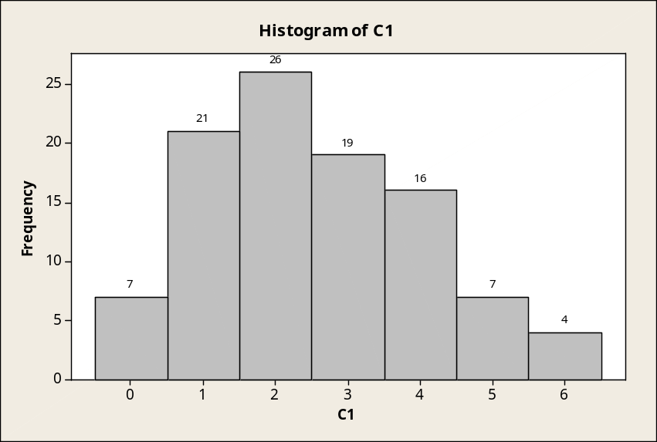

b. Poisson probabilities with λ = 2.35.

Poisson with mu = 2.35000
x P( X = x)
0 0.0954
1 0.2241
2 0.2633
3 0.2063
4 0.1212
5 0.0570
6 0.0223
7 0.0075
8 0.0022
9 0.0006
10 0.0001
11 0.0000

c. Repeating part a. The resulting distribution of the simulated values is shown below.
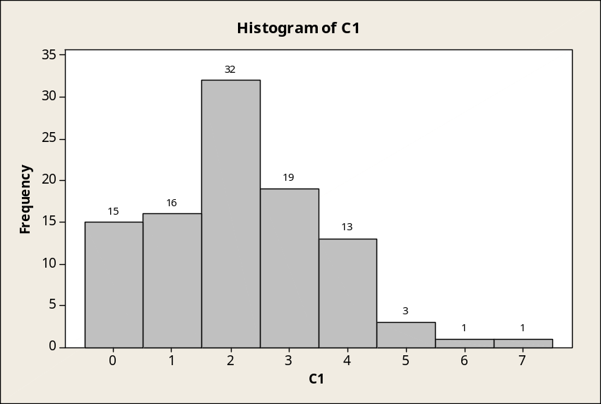

d. The printout in part d will be identical to the one in part b.
e. Repeating part a is the equivalent of selecting a new set of random observations from the probability distribution described in part b. The frequency distribution is a breakdown of the actual observations; the probability distribution is the relative frequency distribution that theoretically should occur.

6.53 c/c/m
a. and b. Simulation of 50 observations from a binomial distribution with π = 0.20 and n = 5.
The distribution of simulated values is shown below. The distribution tails off toward the
higher values, (positive skewness).
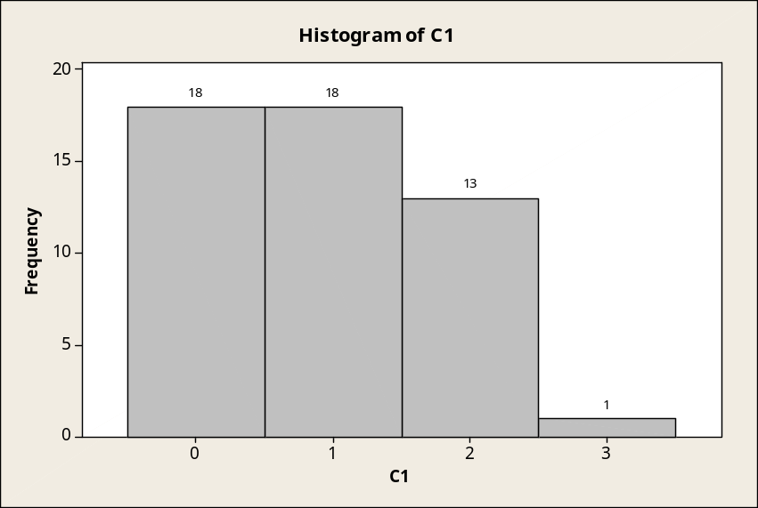

c. Repeating parts a and b, but with 500 simulated observations, the distribution of simulated values is shown below. As with the previous distribution, this one tails off toward the higher values.
The amount of skewness does not appear to be appreciably different from the distributions in parts a and b.
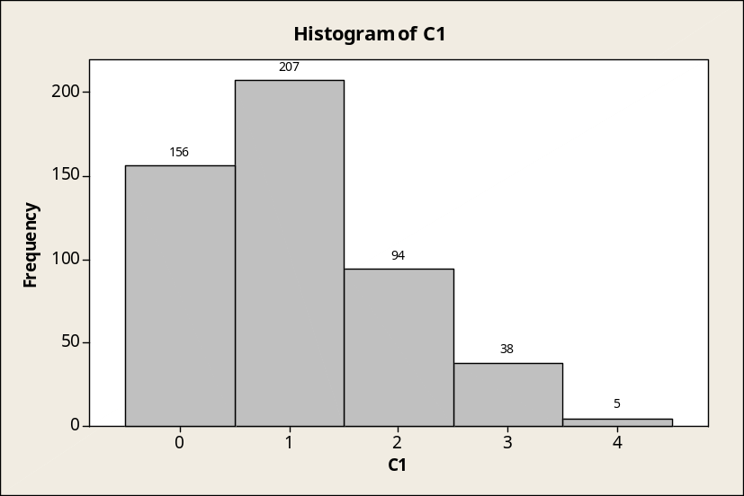

d. Even for very large numbers of observations, the distribution would not become symmetrical; but the observed relative frequencies would approach the theoretical probabilities associated with the underlying binomial distribution with n = 5 and π = 0.2. This is due to the law of large numbers.

CHAPTER EXERCISES
6.54 p/a/m As shown in the Minitab printout below, P(x ≤ 2) is 0.9739. The chances are very good that passengers who become ill will have a bed on which to recuperate.

Binomial with n = 6 and p = 0.120000
x P( X <= x)
0 0.4644
1 0.8444
2 0.9739
3 0.9975
4 0.9999
5 1.0000

6.55 p/a/m For a span of 50,000 flying hours, the expected value is 1.0/2, or 0.5 crashes per 50,000 flying hours. The probability is 0.9098 that no more than one crash will occur in the next 50,000 flying hours.

Poisson with mean = 0.5

x P( X <= x )
0 0.60653
1 0.90980
2 0.98561
3 0.99825
4 0.99983
5 0.99999
6 1.00000

6.56 p/a/m Using either the computer or the table of cumulative binomial probabilities for n = 5 and
π = 0.3, P(x ≥ 3) = 1 - P(x ≤ 2) = 1 - 0.8369 = 0.1631. The prospects look somewhat dim that Bill will meet his quota by tomorrow morning. The Minitab printout of cumulative probabilities is shown below:

Binomial with n = 5 and p = 0.300000
x P( X <= x )
0.00 0.1681
1.00 0.5282
2.00 0.8369
3.00 0.9692
4.00 0.9976
5.00 1.0000

6.57 d/p/m No, it would not be appropriate. The probability of a success would not be the same from
one trial (customer) to the next. For example, if this car were sold to the first of the three customers,
the probability of selling the car to either of the other two customers would become zero.

6.58 p/a/m The probability distribution would be binomial, with n = 3 and π = 0.158:

Binomial with n = 3 and p = 0.158

x P( X = x )
0 0.596948
1 0.336049
2 0.063059
3 0.003944

6.59 p/a/m The probability distribution would be binomial, with n = 5 and π = 0.2. We can either use the computer or refer to the table of individual binomial probabilities for n = 5 and π = 0.2.

Binomial with n = 5 and p = 0.2

x P( X = x )
0 0.32768
1 0.40960
2 0.20480
3 0.05120
4 0.00640
5 0.00032

6.60 p/a/m An erroneous call to the police will be made if two or more of the devices are activated on the same night. Using the cumulative binomial probabilities below,
P(x ≥ 2) = 1 - P(x ≤ 1) = 1 - 0.9185 = 0.0815.

Binomial with n = 5 and p = 0.100000
x P( X <= x)
0 0.5905
1 0.9185
2 0.9914
3 0.9995
4 1.0000

6.61 p/a/m The mine will operate all day on those days when x ≤ 2. Using either the computer or the "1.2" column of the table of Poisson cumulative probabilities, P(x ≤ 2) = 0.8795. On 87.95% of the days, the mine will be operational throughout the day.

6.62 p/a/m Because the shipment is described as "very large," it is assumed that the population size is such that the probability of a success (a defect) on any given trial will be approximately constant.
With π = 0.20, and with n = 15 trials, P(x ≥ 2) = 1 - P(x ≤ 1) = 1 - 0.1671 = 0.8329, the probability that the shipment will be rejected.

Binomial with n = 15 and p = 0.200000
x P( X <= x)
0 0.0352
1 0.1671
2 0.3980
3 0.6482
(partial printout)

6.63 p/a/m With N = 20, n = 4, and s = 2, the probability that the sample will include 1 or more defective bearings can be calculated as P(x ≥ 1) = 1 - P(x = 0). The following calculations lead to the requested probability:

P(x = 0), 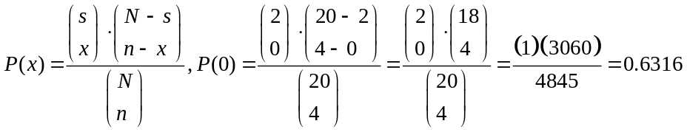

and P(x ≥ 1) = 1 - P(x = 0) = 1 - 0.6316 = 0.3684. The corresponding Excel and Minitab printouts are shown below.
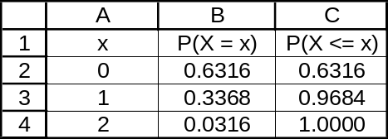

Hypergeometric with N = 20, M = 2, and n = 4
x P( X = x )
0 0.631579
1 0.336842
2 0.031579

Hypergeometric with N = 20, M = 2, and n = 4
x P( X <= x )
0 0.63158
1 0.96842
2 1.00000

6.64 p/a/m With N = 25, n = 5, and s = 15, the probability that the committee will include at least three Republicans can be calculated as P(x ≥ 3) = 1 - P(x ≤ 2). The following calculations lead to the requested probability:

P(x = 0), 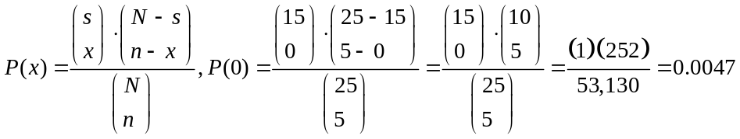

P(x = 1), 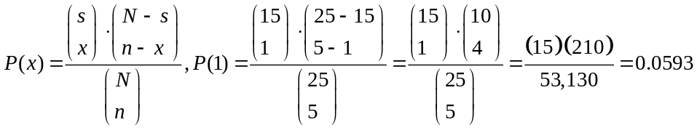

P(x = 2), 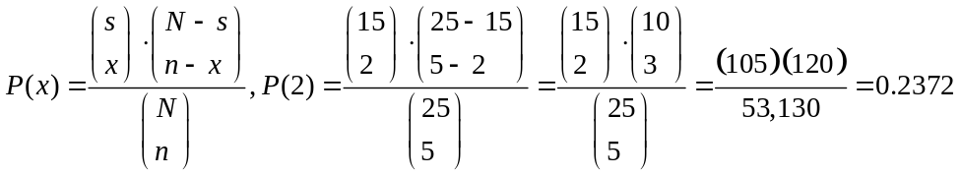

and P(x ≥ 3) = 1 - P(x ≤ 2) = 1 - 0.0047 - 0.0593 - 0.2372 = 0.6988. We can also use the Excel or Minitab cumulative probabilities below to obtain P(x ≥ 3) = 1 - P(x ≤ 2) = 1 - 0.3012 = 0.6988.

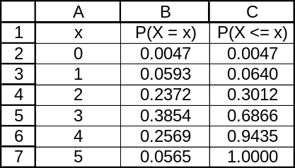

Hypergeometric with N = 25, M = 15, and n = 5
x P( X = x )
0 0.004743
1 0.059289
2 0.237154
3 0.385375
4 0.256917
5 0.056522

Hypergeometric with N = 25, M = 15, and n = 5
x P( X <= x )
0 0.00474
1 0.06403
2 0.30119
3 0.68656
4 0.94348
5 1.00000

6.65 p/a/m Using the hypergeometric distribution, with N = 50, n = 2, and s = 5, the probability that the sample will include exactly x = 1 of our two friends can be calculated as:

P(x = 1), 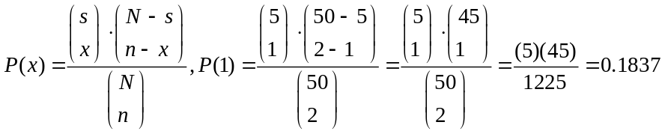

Using Minitab and the hypergeometric distribution, we also find that P(x = 1) is 0.1837.

Hypergeometric with N = 50, M = 5, and n = 2
x P( X = x )
0 0.808163
1 0.183673
2 0.008163

6.66 p/a/m With N = 15, n = 5, and s = 7, the probability that exactly two of the assigned officers will have had advanced training in crowd control can be calculated as:

P(x = 2), 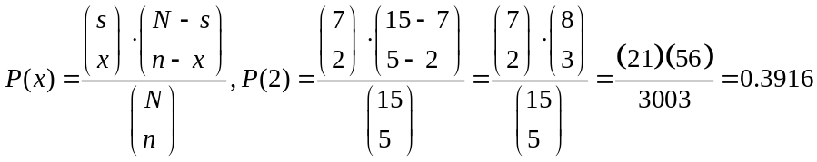

The probability that at least three of the assigned officers will have had advanced training in crowd control can be calculated as P(x = 3) + P(x = 4) + P(x = 5), or the sum of the following probabilities:

P(x = 3), 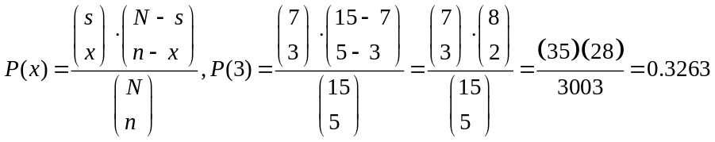

P(x = 4), 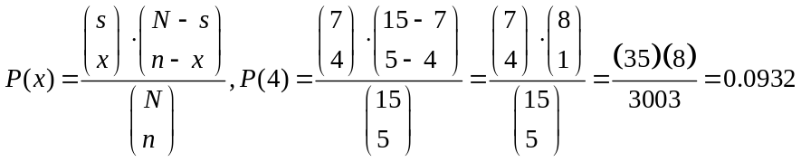

P(x = 5), 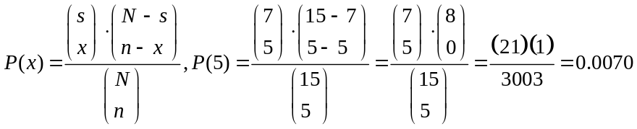

We can also compute calculate P(x ≥ 3) as 1 - P(x ≤ 2). Using either the Excel or Minitab cumulative probabilities, P(x ≥ 3) = 1 - P(x ≤ 2) = 1 - 0.5734, or 0.4266.

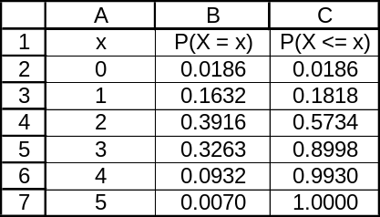

Hypergeometric with N = 15, M = 7, and n = 5
x P( X = x )
0 0.018648
1 0.163170
2 0.391608
3 0.326340
4 0.093240
5 0.006993

Hypergeometric with N = 15, M = 7, and n = 5
x P( X <= x )
0 0.01865
1 0.18182
2 0.57343
3 0.89977
4 0.99301
5 1.00000

6.67 p/a/m If 5 flaws occur per 2000 feet of tubing, the expected number of flaws in 200 feet will be 5(200/2000), or 0.5. The average for the associated Poisson distribution is λ = 0.5 flaws per 200 feet.
Let x = observed number of flaws per 200 feet.
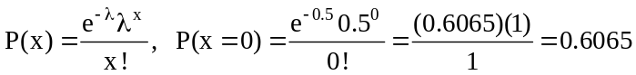
This result can also be obtained from the table of Poisson individual probabilities or by using the computer.

6.68 p/a/d For a single 200-foot roll, the probability of zero flaws is 0.6065, as was determined in exercise 6.67. For x = the number of rolls which are flawless, the binomial distribution with n = 8 and
π = 0.6065 will apply. Using Minitab, we find P(x ≤ 3) = 0.1638:

Binomial with n = 8 and p = 0.606500
x P( X <= x)
0 0.0006
1 0.0077
2 0.0459
3 0.1638
4 0.3909

6.69 p/a/m Using the binomial distribution, with n = 5 and π = 0.50, the probability that exactly three of these families will have a net worth less than $93,000 is P(x = 3):
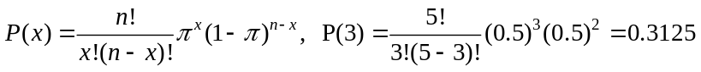

We can also use the table of binomial individual probabilities or the computer. Using Minitab:

Binomial with n = 5 and p = 0.5

x P( X = x )
0 0.03125
1 0.15625
2 0.31250
3 0.31250
4 0.15625
5 0.03125
6.70 p/a/d This is a Poisson distribution with mean λ = 0.2 breakdowns during a round-trip. We can use the table of Poisson individual probabilites or the computer. Using Minitab:

Poisson with mu = 0.200000
x P( X = x )
0.00 0.8187
1.00 0.1637
2.00 0.0164
3.00 0.0011

a. P(x = 0) = 0.8187
b. Assuming the chance that any individual truck will not break down π = 0.8187, we want to find the chance that at least 2 will not break down. This is then a binomial distribution with π = 0.8187 and
n = 3. The desired probability is P(x ≥ 2) = P(x = 2) + P(x = 3). Using Minitab:

Binomial with n = 3 and p = 0.818700
x P( X = x)
0 0.0060
1 0.0807
2 0.3646
3 0.5487

P(x ≥ 2) = P(x = 2) + P(x = 3) = 0.3646 + 0.5487 = 0.9133

6.71 p/a/m For a company that employs 200 coal miners, the expected number of debilitating injuries or illness during the year will be 2(3.6) and the mean for the associated Poisson distribution is λ = 7.2.
Let x = the number of workers who suffer debilitating injury or illness during the year. Using the “7.2” column of the table of cumulative Poisson probabilities, we can calculate
P(x ≥ 10) = 1 - P(x ≤ 9), or P(x ≥ 10) = 1 - 0.8096 = 0.1904. The corresponding Minitab cumulative distribution is shown below.

Poisson with mean = 7.2
x P( X <= x )
0 0.000747
1 0.006122
2 0.025474
3 0.071917
4 0.155516
5 0.275897
6 0.420356
7 0.568941
8 0.702668
9 0.809650
10 0.886677
11 0.937094
(partial printout)

6.72 p/a/m For the county with 500 persons in this age group, the expected number who experience flu-associated problems is 1200(500/100,000), or 6.0, and the mean for the associated Poisson distribution is λ = 6.0. Let x = the number of county persons in this age group who have flu problems. Using the “6.0” column of the table of cumulative Poisson probabilities, we can look up the probability that no more than 5 people will have flu problems as P(x ≤ 5) = 0.4457.

We can also determine P(x ≥ 15) = 1 - P(x ≤ 14), or P(x ≥ 15) = 1 - 0.9986 = 0.0014. This is an extremely low probability, and it is very unlikely that the number of flu problems among the elderly in this county could be this high just by chance.

Poisson with mean = 6
x P( X <= x )
0 0.00248
1 0.01735
2 0.06197
3 0.15120
4 0.28506
5 0.44568
6 0.60630
7 0.74398
8 0.84724
9 0.91608
10 0.95738
11 0.97991
12 0.99117
13 0.99637
14 0.99860
15 0.99949
16 0.99983
(partial printout)

6.73 p/a/d The distribution is Poisson with λ = 3.0 calls per minute. The system can handle as many as
5 calls per minute. Given this information, the probability that the system will be overloaded in the next minute is P(x ≥ 6) = 1 - P(x ≤ 5) = 1 - 0.9161 = 0.0839. This can be found from the table of Poisson cumulative probabilities or by using the computer.

6.74 p/a/d The probability that the gorilla will correctly "predict" the outcome of any individual game is π = 0.5. (For purposes of the exercise, the very small possibility of a tie is not considered.) For n = 20 games, 13.16% of the gorilla population would be at least as lucky as the celebrity gorilla in the exercise description. Using either the computer or the binomial cumulative probabilities table,
P(x ≥ 13) = 1 - P(x ≤ 12) = 1 - 0.8684 = 0.1316.

6.75 p/a/m For a binomial distribution with n = 10 and π = 0.90, the cumulative probabilities for
x = number of companies actively involved in data warehousing can be obtained using either the binomial cumulative probability table or the computer. Shown below is the Minitab printout for x values between 5 and 10.

Binomial with n = 10 and p = 0.900000
x P( X <= x )
5.00 0.0016
6.00 0.0128
7.00 0.0702
8.00 0.2639
9.00 0.6513
10.00 1.0000

The probability that at least 7 of the companies are actively involved in data warehousing is
P(x ≥ 7) = 1 - P(x ≤ 6) = 1 - 0.0128, or 0.9872.

6.76 p/a/m For a Poisson distribution with λ = 1.3, cumulative probabilities for x = the number of complete rounds played by a randomly selected golfer can be obtained using either the Poisson cumulative probability table or the computer. Below is the Minitab printout for x values between 0 and 4.

Poisson with mu = 1.30000
x P( X <= x )
0.00 0.2725
1.00 0.6268
2.00 0.8571
3.00 0.9569
4.00 0.9893

The probability that the golfer will play at least 2 complete rounds is
P(x ≥ 2) = 1 - P(x ≤ 1) = 1 - 0.6268, or 0.3732.

6.77 p/a/m For a binomial distribution with n = 9 and π = 0.10, the cumulative probabilities for
x = number of computers that are inoperable can be obtained using either the binomial cumulative probability table or the computer. Shown below is the Minitab printout for x values between 0 and 6.

Binomial with n = 9 and p = 0.100000
x P( X <= x )
0.00 0.3874
1.00 0.7748
2.00 0.9470
3.00 0.9917
4.00 0.9991
5.00 0.9999
6.00 1.0000

In order to have at least 8 computers that work, the number of inoperable computers must be no more than 1. As shown in the printout above, P(x ≤ 1) = 0.7748.

6.78 p/a/m For a binomial distribution with n = 100, π = 0.05, and x = the number of patients who get a hospital-borne infection, we can use the computer to determine P(x ≥ 14). Given the printout below,
P(x ≥ 14) = 1 - P(x ≤ 13) = 1 - 0.9995, or 0.0005.

Binomial with n = 100 and p = 0.0500000
x P( X <= x )
4.00 0.4360
5.00 0.6160
6.00 0.7660
7.00 0.8720
8.00 0.9369
9.00 0.9718
10.00 0.9885
11.00 0.9957
12.00 0.9985
13.00 0.9995
14.00 0.9999
15.00 1.0000

If the true population proportion for Grove Tree Mountain Hospital were really 0.05, it would be extremely unlikely that 14 or more patients in a sample of 100 would get a hospital-borne infection.
If such a result were observed, the hospital should immediately attempt to find the source of the problem and attempt to effect a solution.
Alternatively, we can use the Poisson approximation to the binomial distribution. In this case, the mean of the Poisson distribution would be E(x) = λ = nπ = 100(0.05) = 5.0 infections.

6.79 p/a/m For a binomial distribution with n = 40, π = 0.02, and x = the number of tires with surface blemishes, we can use the computer to determine P(x ≥ 5). Given the printout below,
P(x ≥ 5) = 1 - P(x ≤ 4) = 1 - 0.9988, or 0.0012.

Binomial with n = 40 and p = 0.0200000
x P( X <= x )
0.00 0.4457
1.00 0.8095
2.00 0.9543
3.00 0.9918
4.00 0.9988
5.00 0.9999
6.00 1.0000

If the true population proportion were really 0.02, it would be extremely unlikely to have 5 or more blemished tires in a sample of 40. The advertising claim is not very believable. Alternatively, we can use the Poisson approximation to the binomial distribution. In this case, the mean of the Poisson distribution would be E(x) = λ = nπ = 40(0.02) = 0.8 tires with blemishes.

6.80 p/a/m Larry and his Lexus: For a Poisson distribution with λ = 0.84, and x = number of defects per vehicle, the Poisson individual probabilities are shown below. The probability that Larry’s Lexus will have exactly 2 problems is shown below as 0.1523.

Poisson with mean = 0.84
x P( X = x )
0 0.431711
1 0.362637
2 0.152307
3 0.042646
4 0.008956
5 0.001505
6 0.000211
7 0.000025

Mark and his Mini: For a Poisson distribution with λ = 1.65, and x = number of defects per vehicle, the Poisson cumulative probabilities are shown below. The probability that Mark’s Mini will have no more than 1 problem is shown below as 0.3169.

Poisson with mean = 1.65
x P( X = x )
0 0.192050
1 0.316882
2 0.261428
3 0.143785
4 0.059311
5 0.019573
6 0.005383
7 0.001269

The probability that neither Larry nor Mark will have a problem is 0.431711*0.192050 = 0.0829.

INTEGRATED CASES

THORNDIKE SPORTS EQUIPMENT

The Thorndikes, having received complaints about the durability of their aluminum racquets, are concerned that one of their aluminum suppliers (Darwood Discount Metals, Inc.) may be providing substandard metal that is contributing to the failures. Of the 1200 Thorndike racquets that have been made from Darwood aluminum, 20 are in the "defectives" bin in the basement.

Ted finds that the percentage of defective aluminum racquets in the industry as a whole is 0.8%, then uses a computer to generate the binomial distribution for n = 1200 (the number of Thorndike racquets made from Darwood aluminum) and π = 0.008 (the proportion of defective aluminum racquets in the industry). The result is Table 6.7 of the text. If Darwood aluminum really is of equal quality versus the industry, there would be only a (1 - 0.9979) = 0.0021 probability that 20 or more of the 1200 racquets would be defective.

Mr. Darwood has assured Luke Thorndike that Darwood aluminum is just as good as any in the industry. However, an interpretation of the data and Table 6.7 suggests that the Thorndikes might be wise to sever their relationship with this supplier. If Mr. Darwood's contention were true, it would be extremely unlikely (probability = 0.0021) that 20 or more defective racquets would be found among the 1200 made from aluminum supplied by his company.

